E-COMMERCE ORDER MANAGEMENT DATABASE SYSTEM

ESTABLISH RELATIONSHIPS

1. Establish Relationships Between Tables
The relationships are established between the Customer, Orders, Order_Details, and Product tables in the E-Commerce Order Management Database System. Foreign key constraints connect the related tables and maintain referential integrity.
Customer–Orders Relationship: The Customer_ID in the Orders table references the Customer_ID in the Customer table. This relationship connects each order to its corresponding customer.
Orders–Order_Details Relationship: The Order_ID in the Order_Details table references the Order_ID in the Orders table. This relationship connects each order detail record to its corresponding order.
Product–Order_Details Relationship: The Product_ID in the Order_Details table references the Product_ID in the Product table. This relationship connects each order detail record to its corresponding product.

2. View Table Relationships
The SHOW CREATE TABLE Orders; command displays the table definition and its foreign key relationship with the Customer table.
The SHOW CREATE TABLE Order_Details; command displays the table definition and its foreign key relationships with the Orders and Product tables.

3. View Table Structures
The DESC Customer; and DESC Product; commands display the structures of the Customer and Product tables, including their column names, data types, and key information.

4. View Foreign Key Constraints
The INFORMATION_SCHEMA.KEY_COLUMN_USAGE query retrieves foreign key details for the Orders and Order_Details tables. It displays the table name, column name, constraint name, referenced table, and referenced column.
This helps verify the relationships established between the tables in the database.

5. Screenshots
- Figure 1: Customer–Orders Relationship (SHOW CREATE TABLE Orders;)
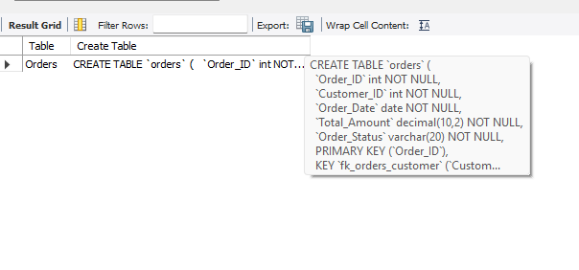
- Figure 2: Orders–Order_Details Relationship (SHOW CREATE TABLE Order_Details;)
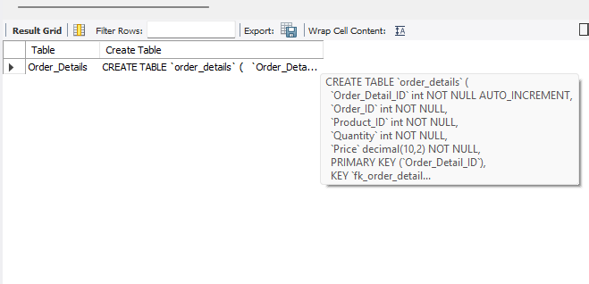
- Figure 3: Customer and Product Table Structures
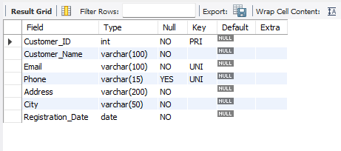

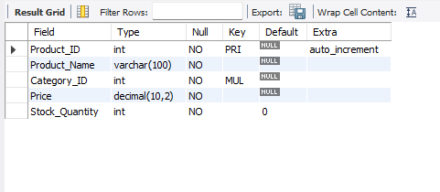
- Figure 4: Foreign Key Constraints Verification
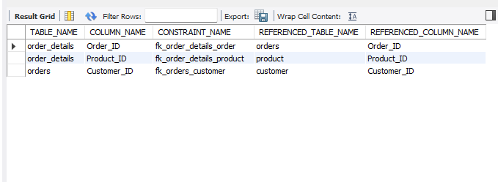

6. Conclusion
The relationships between the Customer, Orders, Order_Details, and Product tables establish the required connections for managing customer orders and associated products. Foreign key constraints maintain referential integrity and help ensure consistency across the E-Commerce Order Management Database System.

